Atomic Review WS name:
- Label the parts of the atom below
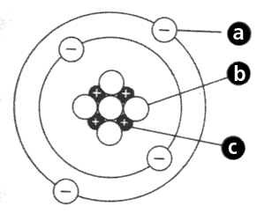
- Fill in the table below
Atom | Atomic # | Mass # | Neutrons | Protons | Electrons
Aluminum
Barium
Xenon
Tungsten

- Fill in the table below
Isotope | Atomic # | Mass # | Neutrons | Protons | Electrons
germanium-64
neon-23
carbon-12
carbon-14

- The element of copper has naturally occurring isotopes with mass numbers of 64 and 65. The relative abundance and atomic masses are 69.2% for mass = 62.93 amu, and 30.8% for mass = 64.93 amu. Calculate the average atomic mass of copper.

