- Write an aufbau diagram for Thallium

- Draw the orbitals for Fluorine

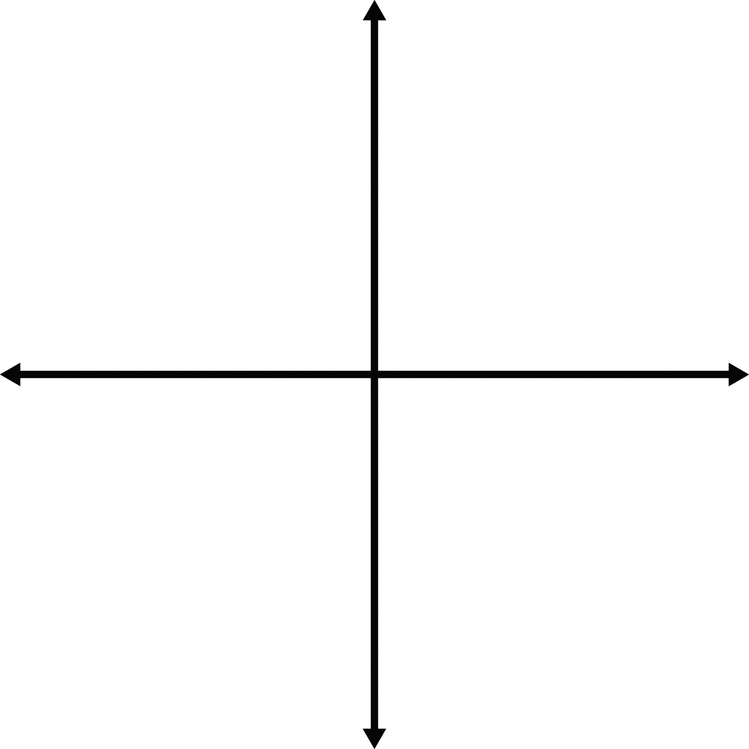

In the space below, write the unabbreviated electron configurations of the following elements:
- Copper______________________________
- Neon_______________________________
- Francium____________________________
- Uranium_____________________________
In the space below, write the abbreviated electron configurations of the following elements:
- Gold_______________________________
- Cobalt______________________________
- Tellurium___________________________
- Einstienium__________________________
Determine what elements are denoted by the following electron configurations:
- 1s²2s²2p⁶3s²3p⁴
____________________
- 1s²2s²2p⁶3s²3p⁶4s²3d¹⁰4p⁶5s¹ ____________________
- [Kr] 5s²4d¹⁰5p³
____________________
- [Xe] 6s²4f¹⁴5d⁶
____________________

Determine which of the following electron configurations are not valid:
- 1s²2s²2p⁶3s²3p⁶4s²4d¹⁰4p⁵ ____________________
- 1s²2s²2p⁶3s³3d⁵
____________________
- [Ra] 7s²5f⁸
____________________
- [Kr] 5s²4d¹⁰5p⁵
____________________

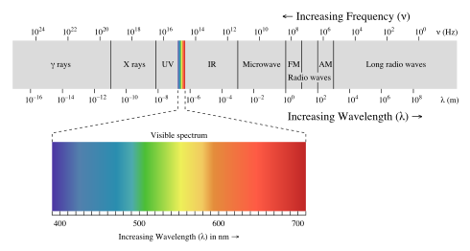
Wave Types  (use Electromagnetic Spectrum handout) | Wavelength (m)  c=2.998 x 10⁸ m/s | Frequency (Hz) | Energy (J)  h=6.626 x 10⁻³⁴
1) |  | 9.751 x 10¹⁸ Hz
2) |  |  | 2.61 x 10⁻¹⁹ J
3) | 5.8762 x 10⁻² m
Answer the following short answer questions.
- Which of the following electron configurations would be considered at its ground state? Why?
  - 1s²2s²2p⁴
  - 1s²2s¹2p²
Why?
- Which of the following electron configurations would be considered at its excited state? Why?
  - 1s²2s²2p⁴
  - 1s²2s¹2p²

Why?

- Describe Hund’s Rule and the Pauli Exclusion Principle.

- Describe the Wave-Particle of Light Theory and how it was discovered. Make sure to list the scientist that were involved and what they contributed.

- Explain how electrons produce light from the ground state to an excited state.

- Explain how the speed of light equation and the energy equation relate to the Electromagnetic Spectrum and photons.

