Making Salt Lab Final
Introduction
During chemistry you have learned many concepts and techniques that have prepared you do this lab. We will be doing a “perfect reaction”, meaning we will have not atoms left over in the product that didn’t react. To do this we must do the stoicheometric calculations. The actual lab for this is very quick; however the prelab will take some time. You cannot start the lab until you have all your calculations finished.
PreLab Questions
Here below are the reactants of the reactions that will be taking place.
Sodium Carbonate as a solid and aqueous Hydrochloric Acid Sodium Chloride, Water, and Carbon Dioxide
- Write the chemical equation with its correct formulas.
- Balance the equation.
- Write the mole ratios that can take place.
- If you start with 5mL of 6M HCl, calculate the amount of sodium carbonate you will need for the reaction. (Hint: The density of 6M HCl is 1.08g/mL)
- Then calculate the amount of Sodium Chloride, Water, and Carbon Dixoide that will be produced.
Safety
Be especially careful when handling the 6M HCl (aq), as it can cause chemical burns to the skin. If any acid spills on you, rinse immediately under running water for up to 15 minutes and report the accident to your instructor. Acid spills may also be neutralized using the sodium bicarbonate solution by the sinks. Also, be sure to exercise appropriate caution when using the Bunsen burner and handling hot equipment.
Experimental Procedure
- Measure and record the mass of your clean dry evaporating dish + watch glass (assembled together with the watch glass acting as a cover on top of the evaporating dish).
- Add YOUR calculated amount of Sodium Carbonate to the evaporating dish.
- Then add the 5mL of HCl slowly while stirring. If it stops bubbling before you add all 5mL in record that in your observations.
- Assemble the stand, ring clamp and wire gauze apparatus for heating as shown on the next page. Cover the evaporating dish with the watch glass and place it on the wire gauze
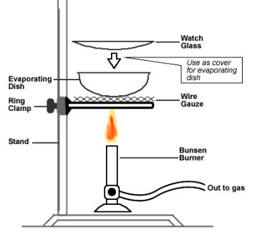
- Gently heat the solution in the covered evaporating dish with a Bunsen burner flame in order to remove the water generated in the reaction (as well as any excess HCl present). The flame should be adjusted to a lower temperature and wafted under the evaporating dish constantly. Continue heating until the contents are completely dry. Note that the watch glass cover should also be dry!
- After allowing the evaporating dish to cool to room temperature, measure and record the mass of the evaporating dish + watch glass + residue (NaCl).
- The waste from this experiment may be disposed of in the sink.
Analysis: Percent Yields – Calculate the theoretical yield of NaCl via standard mass-to-mass stoichiometry. Use your masses of sodium bicarbonate/carbonate reactants weighed out in lab as the starting point and the mole ratios from the balanced equations for these calculations. Then determine your percent yield for the reaction using the calculated theoretical yields along with your experimental yields of NaCl, obtained in lab.
Conclusion-In your conclusion discuss your prelab calculations and if you think your reaction was a “perfection reaction”. Also discuss your post lab results (% yield) and what you would change about your lab to give you better results or how the calculations helped your accuracy.

