Polarity and Hybridization Worksheet

- How is a molecular orbital different from an atomic orbital?

- What is the difference between polarity and a dipole?

- Use hybridization to explain the bonding in methane CH₄ and name the molecular orbital. (show your work)

- What bond type is sp³ hybridization, sp² hybridization, and sp hybridization?

Bond |  | Electronegativity Calculation | Draw bond with partial charges
H-H | Polar bond or Non polar
H-O | Polar bond or Non polar
H-F | Polar bond or Non polar
Br-Br | Polar bond or Non polar
H-Cl | Polar bond or Non polar
H-N | Polar bond or Non polar
- Determine whether each of the following bonds would be polar or nonpolar, and if polar indicate the polarity. Do the calculation for each:

- Determine the Dipole of each of the following molecules by drawing the dipole or writing no dipole.

1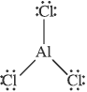 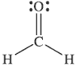 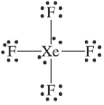

- Fill in the following chart:
 | Calculations:  - Bonding Pair Calculation  - Polarity Calculation | Molecular Geometry: | Molecular Structure:  Include bond angles and polarity. | Dipole Direction  Or  Nonpolar | Hybridization Work | Molecular Orbital
H₂O

I₂

CF₄
NH₃

