Term C Final Review
- Compare and Contrast Molarity and pH scale. (How are they the same and how are they different?)

- Explain what a buffer is and how it would be used in lab when there is an Acid or Base spill.

- Explain why water is neutral and its role in molarity of acids and bases.

- What is the pH of the following hydrogen ion concentrations? Is it an Acid or a Base?
  - 4.32 x 10⁻⁹

  - 2.334 x 10⁻²

  - 5.92 x 10⁻¹²

- The chemistry teacher is making solutions for lab and the lab calls for 250mL of 1.5M H₂SO₄, but the teacher only has 500mL of 6M H₂SO₄. How much 6M H₂SO₄ would the teacher need to make what the lab calls for?

- Explain the 6 types of chemistry.

- Compare and Contrast properties of solids and liquids (tell how they are the same and different)

- Interpret the Phase Diagram and answer the following questions.
- At which temperature is the triple point?

- At what range in pressure does a solid exist?

- As temperature and pressure increase to their limit, on the chart, what state of matter exists?

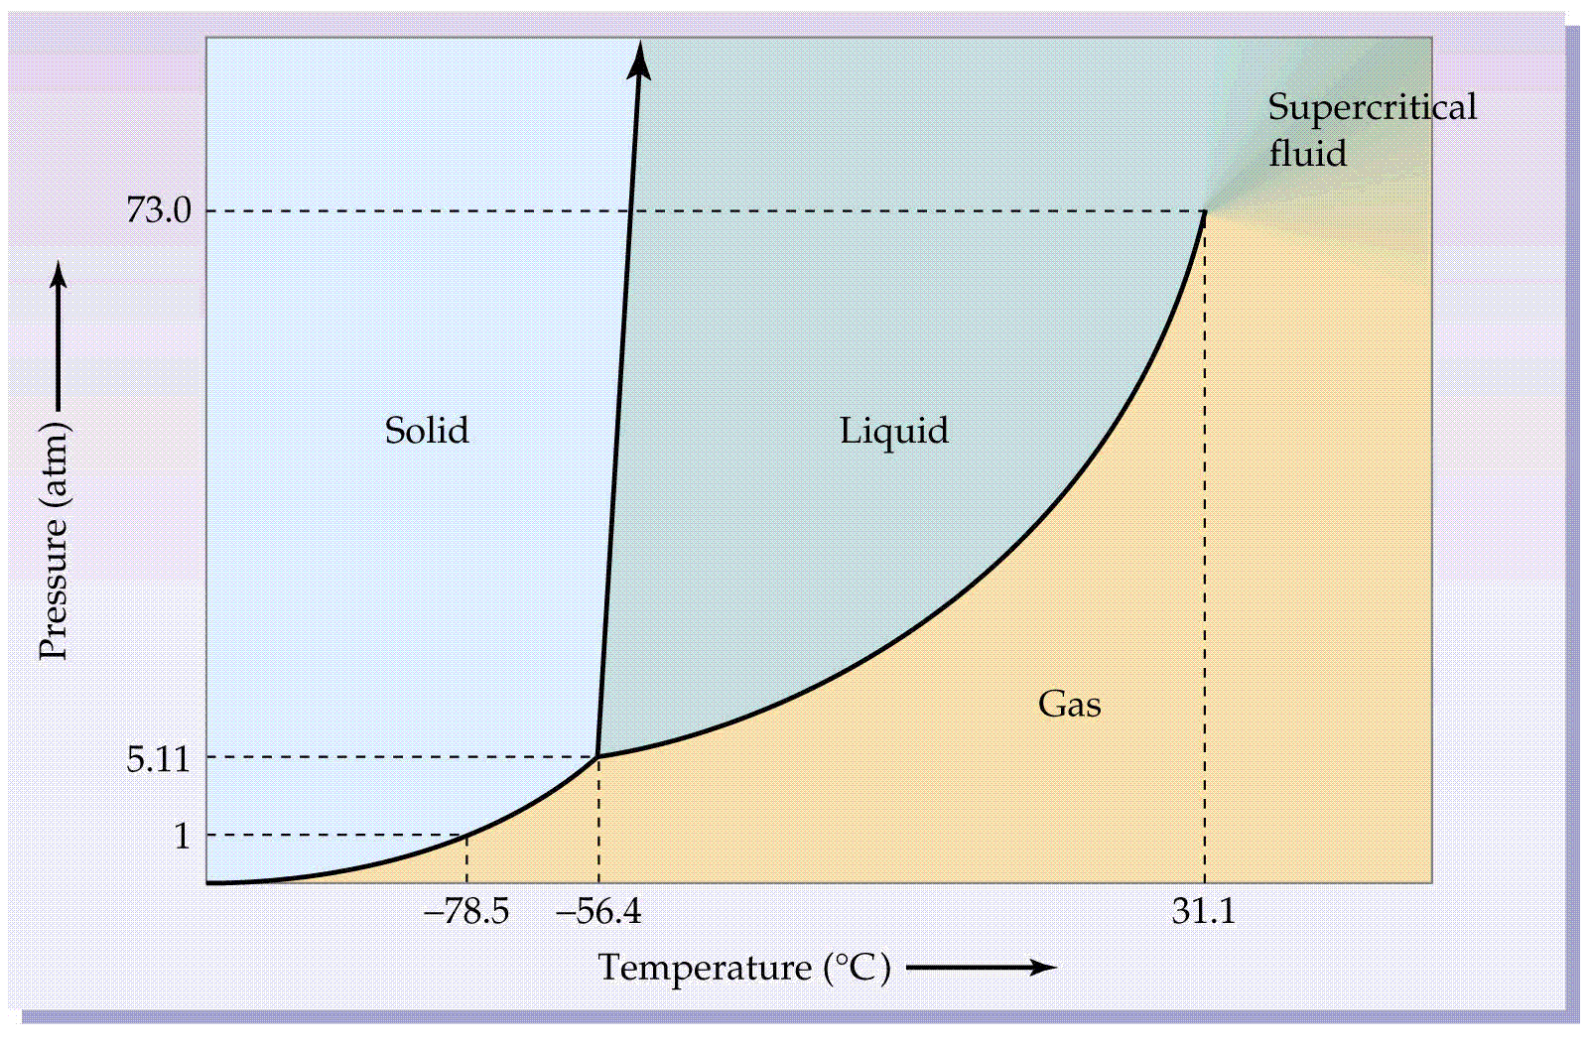

- To explain phase change use the following words and show how they are connected.
  - plasma
  - gas
  - liquid
  - solid
  - ionization
  - vaporization
  - melting
  - deposition
  - deionization
  - sublimation
  - freezing
  - condensation

- Name the separation techniques and a description of each.

- Name the 4 types of crystals and explain each.

- To explain phase change use the following words and show how they are connected.
  - plasma
  - gas
  - liquid
  - solid
  - ionization
  - vaporization
  - melting
  - deposition
  - deionization
  - sublimation
  - freezing
  - condensation

- List 3 examples of qualitative data and 3 examples of quantitative data.

- Compare and Contrast precision and accuracy (how are they the same, how are they different)

- Calculate the % yield and the percent error for each group.
Groups | Starting | Weight of Beaker | Weight of Beaker and copper | Ending
1 | 5.003 | 26.571 | 31.470
2 | 5.017 | 57.233 | 60.100

- Calculate % yield for group 1 and group 2. Which group has the best results?

- Calculate the % error for each group. Are the groups precise? Is either or both groups accurate?

- FIRE EXTINGUISHERS: A firefighter is trying to figure out which type of fire extinguisher (CO₂, water, or dry chemical) will put out fires the fastest. Think about the issue being tested and imagine an appropriate experiment to determine which type of fire extinguisher can extinguish fires the fastest. Then, identify the key elements of the experimental design listed below.

independent variable(s): ____________________________________________________________________

dependent variable: ________________________________________________________________________

list 3 variables that should be held constant: _____________________________________________________

What would you use as the control in this experiment._____________________________________________

- The diameter of a carbon atom is 0.00000005644 micrometers. What is the best way to express this number?

- What is the result of adding 6.5 x 10⁵ and 2.5 x 10³?

- What is the result of multiplying 2.5 x 10⁷ by 3.5 x 10⁻⁸ ?

- What is the result of subtracting 5.5 x 10⁴ and 8.5 x 10⁵ ?

- What is the result of dividing 6.7 x10²⁴ by 9.4 x 10⁻¹⁴?

- What is the volume of a salt crystal measuring 2.44 x 10⁻² m by 1.4 x 10⁻³ by 8.4 x 10⁻³ m?

- Using the volume above calculate the density of the salt crystals if the mass is 3.75x 10⁻⁵g?

- What is the mass of 8.09x 10⁵ µm³ of alcohol if the density of alcohol is 0.70g/mL?

- What is the temperature of -36°C expressed in degrees K and F?

- The quantity 6.5x10⁵ pg expressed in mg?

- A bath tub leaks water at the rate of 22.23 mL/sec. If the bath tub is not repaired, what volume of water in gallons will it leak in a year? (0.2461 gallons = 1 liter)

- Convert 8.25X10²cg to nanograms.

- Fill in the table below
Isotope | Atomic # | Mass # | Neutrons | Protons | Electrons | Valence # of Shells  Electrons
Silicon

Silicon - 29
Silicon– 24

Cesium

- Which of the following is written in correct isotope form for the element of nitrogen containing 5 neutrons?

  - Nitrogen -7
  - Nitrogen-8
  - Nitrogen-12

  - Nitrogen-15
  - None of the above

- An imaginary element X is composed of 70.0 percent of the isotope X-70 and 30.0 percent of the isotope X-75. Estimate the atomic mass of element X.(2 points)

- For the following elements state the charge of the ion. (2 points)
Atom | Charge of ion
Calcium
Chlorine

- Name the element for the following: (3 points)
  - Has 3 valence electrons in the 5 shell

  - Halogen in the 6th period

  - Highly electronegative element with the largest atomic radius in its group

- Fill in the following table using your periodic table relating to ionization energy, electronegativity, atomic size, and ionic size. (8 points)
Which atom has a larger atomic size? | Which atom has a larger ionic size? | Which atom has more Electronegativity? | Which atom has the highest ionization energy?
Rb or Cl | Rb or Cl | Rb or Cl | Rb or Cl
Sn or F | Sn or F | Sn or F | Sn or F

- In the periodic table below label the following important families. Then circle all 4 blocks and label them AND label each of the A and B groups. (10 points)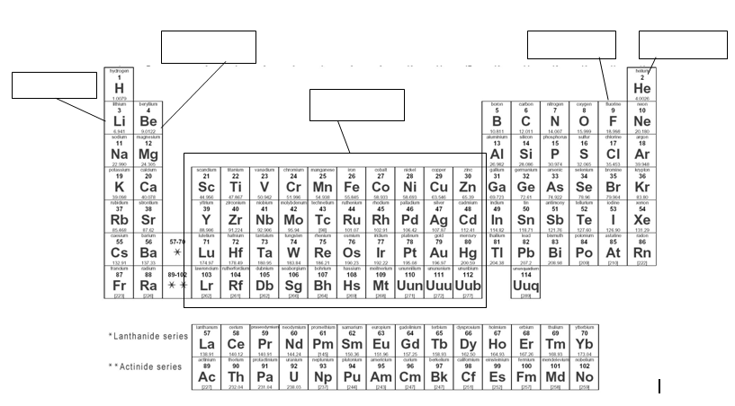

- Draw an Aufbau Diagram and do the Noble Gas notation for Bismuth

- Do the electron configuration and draw Aragon on an x,y,z axis

- Label the wave below.

- It takes 8.17 X 10⁻¹⁹ J of energy to remove one electron from a gold surface. What is the maximum wavelength of light capable of causing this effect? Hint: you have to use two equations.

- Cosmic rays are high-energy radiation from outer space. What is the frequency of a cosmic ray that has a wavelength of 2.67 x 10⁻¹³m when it reaches Earth? Which two types of rays would cosmic rays be most related to?

