What scientists were responsible for the Wave-Particle of Light Theory?

In the diagram below, identify the parts of a wave by using the provided definitions.
#____ = crest The highest point of the wave above the line of origin.
#____ = trough The lowest point of the wave below the line of origin.
#____ = line of origin Signifies the original position of the medium.
#____ = wavelength The distance between two consecutive crests.
#____ = amplitude The distance from the line of origin to a crest or trough of a wave.
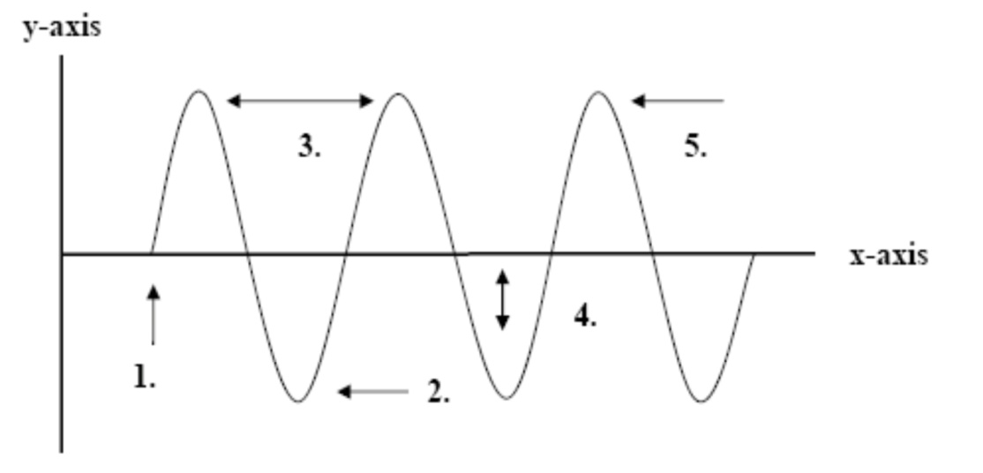

In space below, draw the following requests:
- A wave with high frequency
- A wave with low frequency
- A wave with a low amplitude
- A wave with high amplitude

Which drawing above (1-4) has the longest wavelength?
Which drawing above (1-4) has the shortest wavelength?

For the chart below calculate the wavelength, frequency, or energy of the wave. Show your work in the boxes for credit.
Wavelength (m)  c=2.998 x 10⁸ m/s | Frequency (Hz) | Energy (J)  h=6.626 x 10⁻³⁴
 | 5.451 x 10⁶ Hz
 |  | 4.414 x 10⁻¹⁹ J
 | 7.10 x 10¹⁴ Hz
422nm
4.257cm
 |  | 3.2 x 10⁻¹⁹ J

